ANNUAL REPORTS-2026
  - FITNESS AND WELLNESS CLUB
EVERY YEAR THERE IS A ANNUAL REPORT SUBMISSION OF EVERY CLUB AND THIS IS RELATED TO FITNESS CLUB ON THE YEAR 2025-2026

Club — Annual Report 2025–2026.

Year at a Glance

- Metric | - Achievement
- Active Members | 120+
- Fitness Sessions | 48
- Wellness Sessions | 24
- Fitness Events | 12
- Awareness Programs | 8
- Volunteers | 25+
⭐ Overall Participation

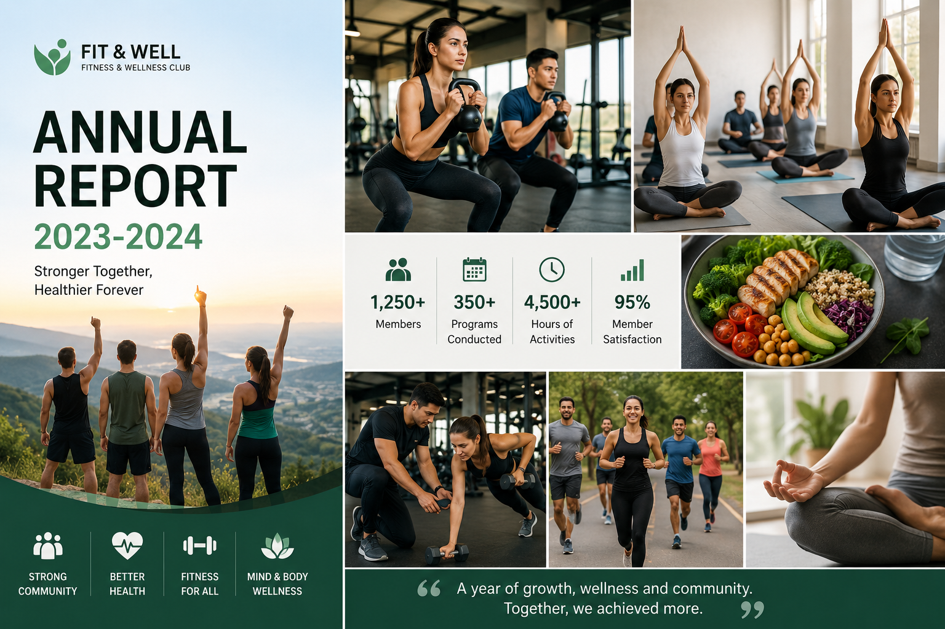

- year of movement, motivation, mindfulness, and meaningful community participation!

- Annual Activity Performance
Club activities throughout the year
Illustrative number of activities conducted during the annual period.
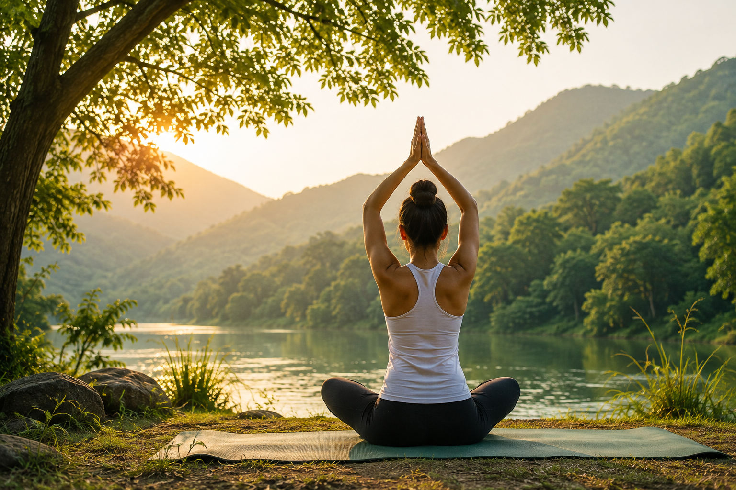

Activities
- Participation Progress
The club maintained strong participation throughout the year. Members actively joined workouts, yoga sessions, fitness challenges, awareness programs, and community activities.

- Fitness Activities ████████████████████ 95%
- Wellness Programs ██████████████████░░ 90%
- Fitness Events █████████████████░░░ 85%
- Awareness Programs ████████████████░░░░ 80%
- Team Activities ███████████████████░ 92%

Budget Summary

CATEGORY | AMOUNT
FITNESS EQUIPMENT | 25000
YOGA AND WELLNESS | 10000
NUTRICIAN PROGRAMS | 8000
EVENT AND CHALLENGES | 12000
REFRESHMENT | 5000
SAFETY AND FIRST AID | 5000
PROMOTION | 5000
MISCELLANEOUS | 5000
TOTAL | 75000

💸 Budget Distribution
🏋️ Equipment █████████████████ 33%
🏆 Events ████████░░░░░░░░ 16%
🧘 Wellness ███████░░░░░░░░░ 13%
🥗 Nutrition █████░░░░░░░░░░░ 11%
💧 Refreshments ███░░░░░░░░░░░░░ 7%
🩹 Safety ███░░░░░░░░░░░░░ 7%
📢 Promotion ███░░░░░░░░░░░░░ 7%
📦 Miscellaneous ███░░░░░░░░░░░░░ 7%

💵 Category | Amount
🏋️ Fitness Equipment | ₹25,000
🧘 Yoga & Wellness | ₹10,000
🥗 Nutrition Programs | ₹8,000
🏆 Events & Challenges | ₹12,000
💧 Refreshments | ₹5,000
🩹 Safety & First Aid | ₹5,000
📢 Promotion | ₹5,000
📦 Miscellaneous | ₹5,000
💰 Total | ₹75,000

- Major Achievements

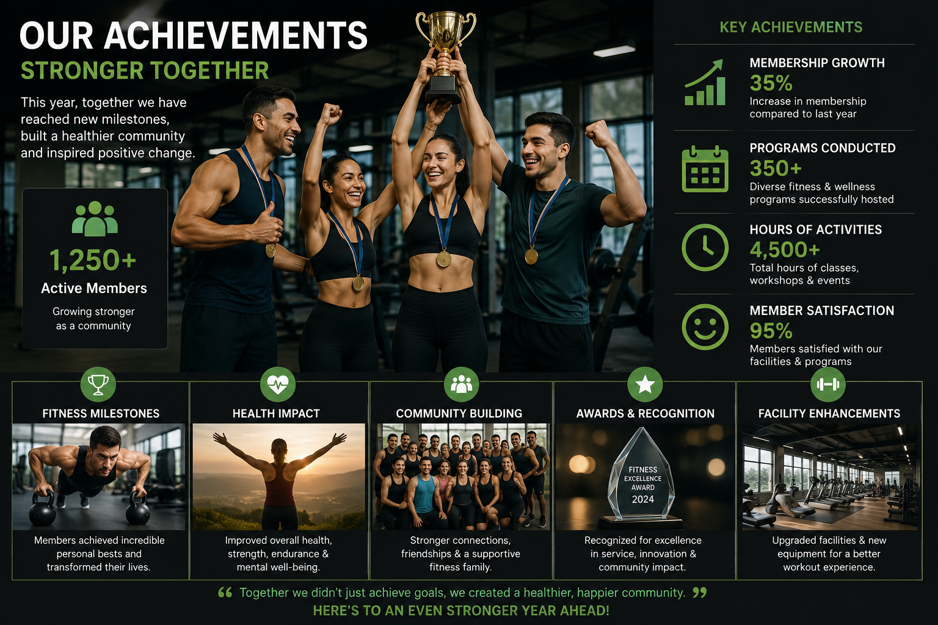
  - 🏋️Conducted regular fitness and workout sessions.
  - 🧘 Promoted yoga, meditation, and stress-management activities.
  - 🥗 Increased awareness of healthy nutrition and hydration.
  - 🏃‍ Organized exciting fitness challenges and competitions.
  - 🤝 Encouraged teamwork and active member participation.
  - 🌱 Created greater awareness of long-term healthy habits.
  - 🎉 Built a positive and energetic wellness community.

📅 Yearly Highlights
📅 Period | 🌟 Highlight
🌱 Q1 | Club orientation & fitness awareness
☀️ Q2 | Group workouts & yoga programs
🍂 Q3 | Fitness challenges & wellness events
❄️ Q4 | Annual fitness event & achievement review

🌈 Overall Impact
The club's activities helped create a culture where fitness became more than exercise. 💪❤️ Members were encouraged to balance physical activity with mental wellness, healthy nutrition, teamwork, and positive daily habits.
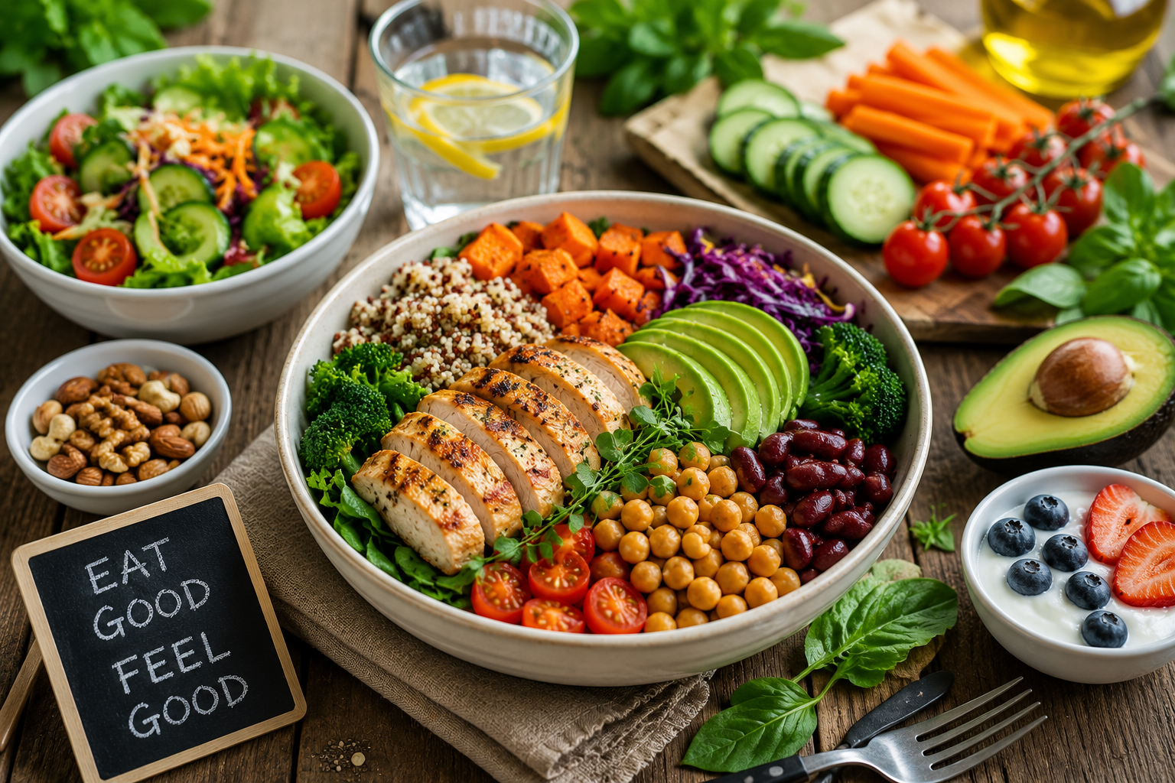
Fitness & Wellness Performance
Annual performance across key fitness and wellness indicators.
category | percentage
💪 Physical Fitness | 94
🧠 Mental Wellness | 90
🥗 Healthy Lifestyle | 87
🤝 Teamwork | 92
😊 Member Satisfaction | 93
- Looking Ahead

The coming year will focus on more participation, better fitness programs, new wellness activities, and stronger community engagement. 🌟
- ❤️
  - Introduce new fitness programs.
  - Expand yoga and mindfulness sessions.
  - Organize more outdoor activities.
  - Conduct additional nutrition workshops.
  - Launch new fitness challenges.
  - Track participation and progress more effectively.
  - Build an even stronger wellness community.

Conclusion
The Fitness & Wellness Club successfully completed a year filled with energy, teamwork, learning, and positive change. 🎉💪🌿 Every workout, wellness session, event, and shared effort contributed to building a healthier and happier community.

“Move with purpose. Live with balance. Grow together.”
❤️ Thank you to every member, volunteer, coordinator, and supporter who made this year successful!

